鸢尾花数据集分析
鸢尾花 （Iris）
- 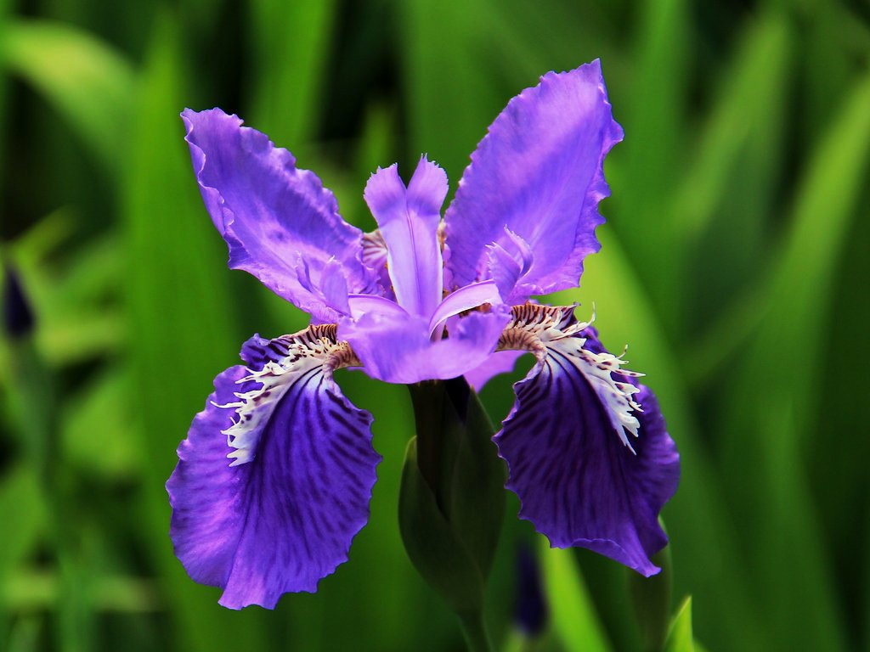
- 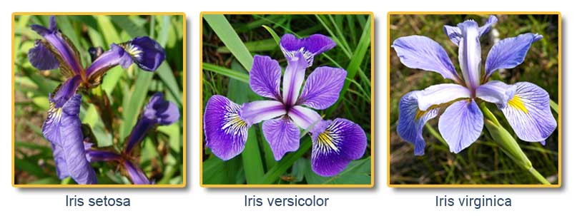品种类别：Setosa、Versicolour、Virginica

- sepal length（萼片长度）
- sepal width（萼片宽度）
- petal length（花瓣长度）
- petal width （花瓣宽度）
- Species（品种类别）：分别是：Setosa、Versicolour、Virginica
- 150条记录如下：
sepal_length,sepal_width,petal_length,petal_width,species
5.1,3.5,1.4,0.2,setosa
4.9,3.0,1.4,0.2,setosa
4.7,3.2,1.3,0.2,setosa
4.6,3.1,1.5,0.2,setosa
5.0,3.6,1.4,0.2,setosa
5.4,3.9,1.7,0.4,setosa
4.6,3.4,1.4,0.3,setosa
5.0,3.4,1.5,0.2,setosa
4.4,2.9,1.4,0.2,setosa
4.9,3.1,1.5,0.1,setosa
5.4,3.7,1.5,0.2,setosa
4.8,3.4,1.6,0.2,setosa
4.8,3.0,1.4,0.1,setosa
4.3,3.0,1.1,0.1,setosa
5.8,4.0,1.2,0.2,setosa
5.7,4.4,1.5,0.4,setosa
5.4,3.9,1.3,0.4,setosa
5.1,3.5,1.4,0.3,setosa
5.7,3.8,1.7,0.3,setosa
5.1,3.8,1.5,0.3,setosa
5.4,3.4,1.7,0.2,setosa
5.1,3.7,1.5,0.4,setosa
4.6,3.6,1.0,0.2,setosa
5.1,3.3,1.7,0.5,setosa
4.8,3.4,1.9,0.2,setosa
5.0,3.0,1.6,0.2,setosa
5.0,3.4,1.6,0.4,setosa
5.2,3.5,1.5,0.2,setosa
5.2,3.4,1.4,0.2,setosa
4.7,3.2,1.6,0.2,setosa
4.8,3.1,1.6,0.2,setosa
5.4,3.4,1.5,0.4,setosa
5.2,4.1,1.5,0.1,setosa
5.5,4.2,1.4,0.2,setosa
4.9,3.1,1.5,0.1,setosa
5.0,3.2,1.2,0.2,setosa
5.5,3.5,1.3,0.2,setosa
4.9,3.1,1.5,0.1,setosa
4.4,3.0,1.3,0.2,setosa
5.1,3.4,1.5,0.2,setosa
5.0,3.5,1.3,0.3,setosa
4.5,2.3,1.3,0.3,setosa
4.4,3.2,1.3,0.2,setosa
5.0,3.5,1.6,0.6,setosa
5.1,3.8,1.9,0.4,setosa
4.8,3.0,1.4,0.3,setosa
5.1,3.8,1.6,0.2,setosa
4.6,3.2,1.4,0.2,setosa
5.3,3.7,1.5,0.2,setosa
5.0,3.3,1.4,0.2,setosa
7.0,3.2,4.7,1.4,versicolor
6.4,3.2,4.5,1.5,versicolor
6.9,3.1,4.9,1.5,versicolor
5.5,2.3,4.0,1.3,versicolor
6.5,2.8,4.6,1.5,versicolor
5.7,2.8,4.5,1.3,versicolor
6.3,3.3,4.7,1.6,versicolor
4.9,2.4,3.3,1.0,versicolor
6.6,2.9,4.6,1.3,versicolor
5.2,2.7,3.9,1.4,versicolor
5.0,2.0,3.5,1.0,versicolor
5.9,3.0,4.2,1.5,versicolor
6.0,2.2,4.0,1.0,versicolor
6.1,2.9,4.7,1.4,versicolor
5.6,2.9,3.6,1.3,versicolor
6.7,3.1,4.4,1.4,versicolor
5.6,3.0,4.5,1.5,versicolor
5.8,2.7,4.1,1.0,versicolor
6.2,2.2,4.5,1.5,versicolor
5.6,2.5,3.9,1.1,versicolor
5.9,3.2,4.8,1.8,versicolor
6.1,2.8,4.0,1.3,versicolor
6.3,2.5,4.9,1.5,versicolor
6.1,2.8,4.7,1.2,versicolor
6.4,2.9,4.3,1.3,versicolor
6.6,3.0,4.4,1.4,versicolor
6.8,2.8,4.8,1.4,versicolor
6.7,3.0,5.0,1.7,versicolor
6.0,2.9,4.5,1.5,versicolor
5.7,2.6,3.5,1.0,versicolor
5.5,2.4,3.8,1.1,versicolor
5.5,2.4,3.7,1.0,versicolor
5.8,2.7,3.9,1.2,versicolor
6.0,2.7,5.1,1.6,versicolor
5.4,3.0,4.5,1.5,versicolor
6.0,3.4,4.5,1.6,versicolor
6.7,3.1,4.7,1.5,versicolor
6.3,2.3,4.4,1.3,versicolor
5.6,3.0,4.1,1.3,versicolor
5.5,2.5,4.0,1.3,versicolor
5.5,2.6,4.4,1.2,versicolor
6.1,3.0,4.6,1.4,versicolor
5.8,2.6,4.0,1.2,versicolor
5.0,2.3,3.3,1.0,versicolor
5.6,2.7,4.2,1.3,versicolor
5.7,3.0,4.2,1.2,versicolor
5.7,2.9,4.2,1.3,versicolor
6.2,2.9,4.3,1.3,versicolor
5.1,2.5,3.0,1.1,versicolor
5.7,2.8,4.1,1.3,versicolor
6.3,3.3,6.0,2.5,virginica
5.8,2.7,5.1,1.9,virginica
7.1,3.0,5.9,2.1,virginica
6.3,2.9,5.6,1.8,virginica
6.5,3.0,5.8,2.2,virginica
7.6,3.0,6.6,2.1,virginica
4.9,2.5,4.5,1.7,virginica
7.3,2.9,6.3,1.8,virginica
6.7,2.5,5.8,1.8,virginica
7.2,3.6,6.1,2.5,virginica
6.5,3.2,5.1,2.0,virginica
6.4,2.7,5.3,1.9,virginica
6.8,3.0,5.5,2.1,virginica
5.7,2.5,5.0,2.0,virginica
5.8,2.8,5.1,2.4,virginica
6.4,3.2,5.3,2.3,virginica
6.5,3.0,5.5,1.8,virginica
7.7,3.8,6.7,2.2,virginica
7.7,2.6,6.9,2.3,virginica
6.0,2.2,5.0,1.5,virginica
6.9,3.2,5.7,2.3,virginica
5.6,2.8,4.9,2.0,virginica
7.7,2.8,6.7,2.0,virginica
6.3,2.7,4.9,1.8,virginica
6.7,3.3,5.7,2.1,virginica
7.2,3.2,6.0,1.8,virginica
6.2,2.8,4.8,1.8,virginica
6.1,3.0,4.9,1.8,virginica
6.4,2.8,5.6,2.1,virginica
7.2,3.0,5.8,1.6,virginica
7.4,2.8,6.1,1.9,virginica
7.9,3.8,6.4,2.0,virginica
6.4,2.8,5.6,2.2,virginica
6.3,2.8,5.1,1.5,virginica
6.1,2.6,5.6,1.4,virginica
7.7,3.0,6.1,2.3,virginica
6.3,3.4,5.6,2.4,virginica
6.4,3.1,5.5,1.8,virginica
6.0,3.0,4.8,1.8,virginica
6.9,3.1,5.4,2.1,virginica
6.7,3.1,5.6,2.4,virginica
6.9,3.1,5.1,2.3,virginica
5.8,2.7,5.1,1.9,virginica
6.8,3.2,5.9,2.3,virginica
6.7,3.3,5.7,2.5,virginica
6.7,3.0,5.2,2.3,virginica
6.3,2.5,5.0,1.9,virginica
6.5,3.0,5.2,2.0,virginica
6.2,3.4,5.4,2.3,virginica
5.9,3.0,5.1,1.8,virginica

鸢尾花分类可视化（任意选取两种特征作图）：
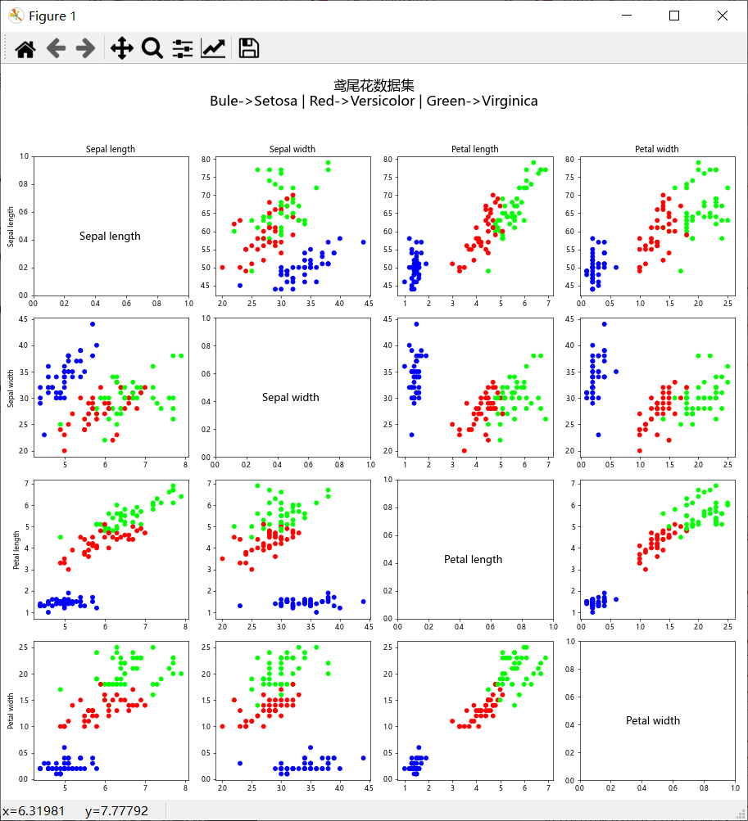

有标签数据（4维），标签1维
机器学习过程：

STEP1： 抽取训练集
STEP2： 剩余数据作为测试集
STEP3： 训练分类器
STEP4： 测试分类器精度
作用： 预测无标签数据

>>> import numpy as np
>>> from sklearn.datasets import load_iris
>>> iris = load_iris()
>>> print(iris.data)
>>> [[5.1 3.5 1.4 0.2]
[4.9 3. 1.4 0.2]
[4.7 3.2 1.3 0.2]
[4.6 3.1 1.5 0.2]
[5. 3.6 1.4 0.2]
[5.4 3.9 1.7 0.4]
[4.6 3.4 1.4 0.3]
[5. 3.4 1.5 0.2]
[4.4 2.9 1.4 0.2]
[4.9 3.1 1.5 0.1]
[5.4 3.7 1.5 0.2]
[4.8 3.4 1.6 0.2]
[4.8 3. 1.4 0.1]
[4.3 3. 1.1 0.1]
[5.8 4. 1.2 0.2]
[5.7 4.4 1.5 0.4]
[5.4 3.9 1.3 0.4]
[5.1 3.5 1.4 0.3]
[5.7 3.8 1.7 0.3]
[5.1 3.8 1.5 0.3]
[5.4 3.4 1.7 0.2]
[5.1 3.7 1.5 0.4]
[4.6 3.6 1. 0.2]
[5.1 3.3 1.7 0.5]
[4.8 3.4 1.9 0.2]
[5. 3. 1.6 0.2]
[5. 3.4 1.6 0.4]
[5.2 3.5 1.5 0.2]
[5.2 3.4 1.4 0.2]
[4.7 3.2 1.6 0.2]
[4.8 3.1 1.6 0.2]
[5.4 3.4 1.5 0.4]
[5.2 4.1 1.5 0.1]
[5.5 4.2 1.4 0.2]
[4.9 3.1 1.5 0.2]
[5. 3.2 1.2 0.2]
[5.5 3.5 1.3 0.2]
[4.9 3.6 1.4 0.1]
[4.4 3. 1.3 0.2]
[5.1 3.4 1.5 0.2]
[5. 3.5 1.3 0.3]
[4.5 2.3 1.3 0.3]
[4.4 3.2 1.3 0.2]
[5. 3.5 1.6 0.6]
[5.1 3.8 1.9 0.4]
[4.8 3. 1.4 0.3]
[5.1 3.8 1.6 0.2]
[4.6 3.2 1.4 0.2]
[5.3 3.7 1.5 0.2]
[5. 3.3 1.4 0.2]
[7. 3.2 4.7 1.4]
[6.4 3.2 4.5 1.5]
[6.9 3.1 4.9 1.5]
[5.5 2.3 4. 1.3]
[6.5 2.8 4.6 1.5]
[5.7 2.8 4.5 1.3]
[6.3 3.3 4.7 1.6]
[4.9 2.4 3.3 1. ]
[6.6 2.9 4.6 1.3]
[5.2 2.7 3.9 1.4]
[5. 2. 3.5 1. ]
[5.9 3. 4.2 1.5]
[6. 2.2 4. 1. ]
[6.1 2.9 4.7 1.4]
[5.6 2.9 3.6 1.3]
[6.7 3.1 4.4 1.4]
[5.6 3. 4.5 1.5]
[5.8 2.7 4.1 1. ]
[6.2 2.2 4.5 1.5]
[5.6 2.5 3.9 1.1]
[5.9 3.2 4.8 1.8]
[6.1 2.8 4. 1.3]
[6.3 2.5 4.9 1.5]
[6.1 2.8 4.7 1.2]
[6.4 2.9 4.3 1.3]
[6.6 3. 4.4 1.4]
[6.8 2.8 4.8 1.4]
[6.7 3. 5. 1.7]
[6. 2.9 4.5 1.5]
[5.7 2.6 3.5 1. ]
[5.5 2.4 3.8 1.1]
[5.5 2.4 3.7 1. ]
[5.8 2.7 3.9 1.2]
[6. 2.7 5.1 1.6]
[5.4 3. 4.5 1.5]
[6. 3.4 4.5 1.6]
[6.7 3.1 4.7 1.5]
[6.3 2.3 4.4 1.3]
[5.6 3. 4.1 1.3]
[5.5 2.5 4. 1.3]
[5.5 2.6 4.4 1.2]
[6.1 3. 4.6 1.4]
[5.8 2.6 4. 1.2]
[5. 2.3 3.3 1. ]
[5.6 2.7 4.2 1.3]
[5.7 3. 4.2 1.2]
[5.7 2.9 4.2 1.3]
[6.2 2.9 4.3 1.3]
[5.1 2.5 3. 1.1]
[5.7 2.8 4.1 1.3]
[6.3 3.3 6. 2.5]
[5.8 2.7 5.1 1.9]
[7.1 3. 5.9 2.1]
[6.3 2.9 5.6 1.8]
[6.5 3. 5.8 2.2]
[7.6 3. 6.6 2.1]
[4.9 2.5 4.5 1.7]
[7.3 2.9 6.3 1.8]
[6.7 2.5 5.8 1.8]
[7.2 3.6 6.1 2.5]
[6.5 3.2 5.1 2. ]
[6.4 2.7 5.3 1.9]
[6.8 3. 5.5 2.1]
[5.7 2.5 5. 2. ]
[5.8 2.8 5.1 2.4]
[6.4 3.2 5.3 2.3]
[6.5 3. 5.5 1.8]
[7.7 3.8 6.7 2.2]
[7.7 2.6 6.9 2.3]
[6. 2.2 5. 1.5]
[6.9 3.2 5.7 2.3]
[5.6 2.8 4.9 2. ]
[7.7 2.8 6.7 2. ]
[6.3 2.7 4.9 1.8]
[6.7 3.3 5.7 2.1]
[7.2 3.2 6. 1.8]
[6.2 2.8 4.8 1.8]
[6.1 3. 4.9 1.8]
[6.4 2.8 5.6 2.1]
[7.2 3. 5.8 1.6]
[7.4 2.8 6.1 1.9]
[7.9 3.8 6.4 2. ]
[6.4 2.8 5.6 2.2]
[6.3 2.8 5.1 1.5]
[6.1 2.6 5.6 1.4]
[7.7 3. 6.1 2.3]
[6.3 3.4 5.6 2.4]
[6.4 3.1 5.5 1.8]
[6. 3. 4.8 1.8]
[6.9 3.1 5.4 2.1]
[6.7 3.1 5.6 2.4]
[6.9 3.1 5.1 2.3]
[5.8 2.7 5.1 1.9]
[6.8 3.2 5.9 2.3]
[6.7 3.3 5.7 2.5]
[6.7 3. 5.2 2.3]
[6.3 2.5 5. 1.9]
[6.5 3. 5.2 2. ]
[6.2 3.4 5.4 2.3]
[5.9 3. 5.1 1.8]]
>>> iris.data[0]

array([5.1, 3.5, 1.4, 0.2])

>>> iris.data[149]

array([5.9, 3. , 5.1, 1.8])

>>> iris.target
array([0, 0, 0, 0, 0, 0, 0, 0, 0, 0, 0, 0, 0, 0, 0, 0, 0, 0, 0, 0, 0, 0, 0, 0, 0, 0, 0, 0, 0, 0, 0, 0, 0, 0, 0, 0, 0, 0, 0, 0, 0, 0, 0, 0,
0, 0, 0, 0, 0, 0, 1, 1, 1, 1, 1, 1, 1, 1, 1, 1, 1, 1, 1, 1, 1, 1,
1, 1, 1, 1, 1, 1, 1, 1, 1, 1, 1, 1, 1, 1, 1, 1, 1, 1, 1, 1, 1, 1,
1, 1, 1, 1, 1, 1, 1, 1, 1, 1, 1, 1, 2, 2, 2, 2, 2, 2, 2, 2, 2, 2,
2, 2, 2, 2, 2, 2, 2, 2, 2, 2, 2, 2, 2, 2, 2, 2, 2, 2, 2, 2, 2, 2,
2, 2, 2, 2, 2, 2, 2, 2, 2, 2, 2, 2, 2, 2, 2, 2, 2, 2])
>>> iris.target[0]
0
>>> iris.target[77]
1

作业：在iris数据集中选取75个数据训练决策树。选取另外50个数据测试训练好的分类器（分析正确率）。

